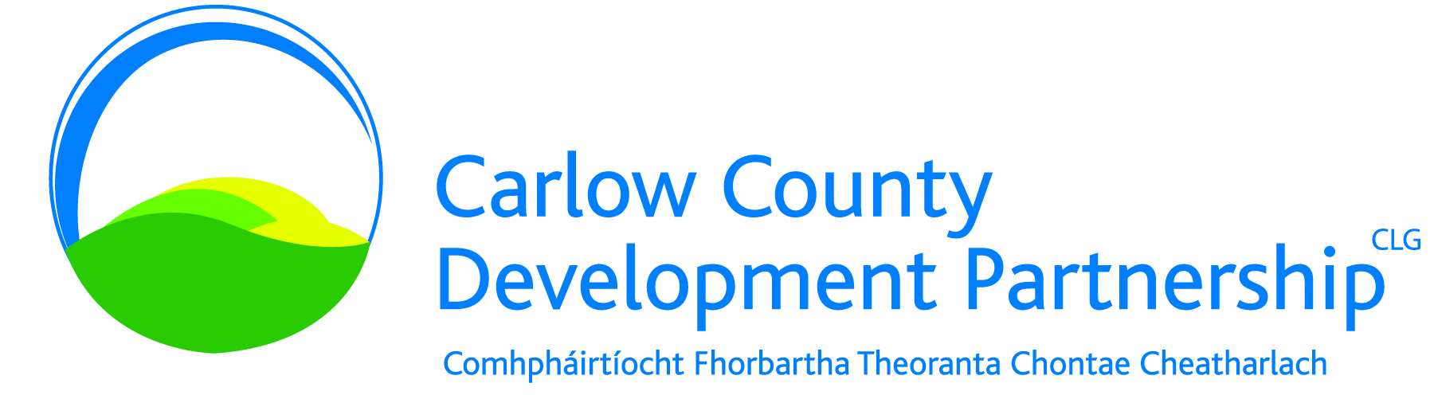

**Community Connection Project**

**Job Title**: Community Link Worker

**Reports to:** Chief Executive Officer

**Located:** Carlow Town and remote working where appropriate

**Duration**: 18 month contract

**Salary:** in the region of €42k

**Job Purpose:** This is an excellent opportunity to join Carlow County Development Partnership CLG in the role of Community Link Worker. Joining a high performing team and reporting to the CEO, the purpose of this role is to engage and work with local communities across Carlow over an 18 month period, helping build community resilience and understanding the facts and realities of the International Protection System and the challenges faced by people seeking asylum, in the context of communities with their own needs and challenges.

Experience in one or more of the following areas is required;

* Community Led Local Development
* Social Inclusion
* Working with marginalised communities and individuals
* Rights based capacity building
* Action Research

**Application Process:** Interested candidates are required to send their Curriculum Vitae with Covering Letter by email to [**eharvey@carlowdevelopment.ie**](mailto:eharvey@carlowdevelopment.ie) on or before **Wednesday 3rd September at 5pm.** Full role profile can be requested from eharvey@carlowdevelopment.ie

All applications received will be acknowledged. Shortlisting will apply. Canvasing will disqualify. Carlow County Development Partnership CLG is an equal opportunities employer.