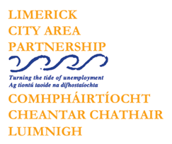

**Limerick City Area Partnership**

**(formerly known as PAUL Partnership Limerick CLG)**

Community Connection Link Worker

Limerick City Area Partnership is an organisation made up of communities, state agencies, social partners, voluntary groups and elected representatives. It works with communities that have benefited least from economic and social development and aims to promote social inclusion and improve the quality of life of people living in communities in Limerick City.

We are currently recruiting for a **Community Connection Link Worker** position on a full-time fixed term basis for an initial period of 18 months.

The Community Connection Project (CCP) will work across Limerick City and County over 18 months to address demographic changes, build community cohesion, and promote cross-cultural awareness and inclusivity. The ideal candidate will have experience in community development, migration trends, cultural diversity, and community engagement.

This is a full-time contract (**35** **hours per week**). Salary is **€40,759 - €49,769** per annum, based on experience.

**A full Job Description and Application Form is available on our website:** <https://www.paulpartnership.ie/vacancies/>

**Only electronic application forms will be accepted. Completed application forms by e-mail to:** [recruitment@paulpartnership.ie](mailto:recruitment@paulpartnership.ie)

**Closing date** **for receipt of completed application form is Tuesday, 8th of July 2025 5.00p.m**

***Shortlisting will apply. Limerick City Area Partnership is an equal opportunities employer.***

***Canvassing will disqualify.***

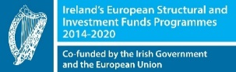 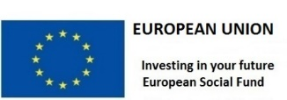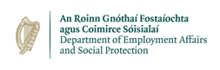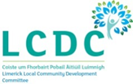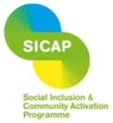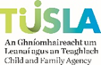

*The Social Inclusion and Community Activation Programme (SICAP) is co-funded by the Government of Ireland, through the Department of Rural and Community Development, and the European Union*.