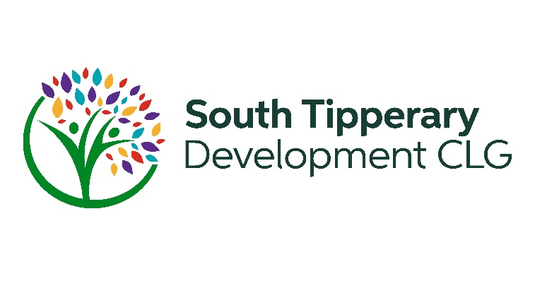
SOUTH TIPPERARY DEVELOPMENT CLG IS RECRUITING
TWO CASE-WORKERS
FOR THE WATERFORD AND SOUTH TIPPERARY LOCAL AREA EMPLOYMENT SERVICE (WSTLAES)
The WSTLAES is responsible for the provision of employment assistance and advice services to jobseekers in the Waterford and South Tipperary area, to help them to enter or return to employment. The jobseekers in the service are primarily those who are long-term unemployed and farthest from the labour market.

The case-worker will be required to provide one-to-one support and guidance to the long-term unemployed and those furthest from the labour market to help them in their progression from unemployment to employment and also liaising with employers, where relevant.

The successful applicant must be client focused, experienced in adult guidance or recruitment and target driven. Integrity and confidentiality are core to this role, as is an ability to communicate effectively. Applicants should be capable of motivating, guiding and leading clients in their self-development. The standard contract will be of a fixed term, concluding on 31st August 2027. The position may be extended beyond that date depending on business requirements. The salary for this post is in line with the Pobal Community Worker scale (€41,531).

KEY REQUIREMENTS
- Three years’ experience of working in employment, enterprise and career
guidance counselling, vocational guidance or social work environment.
- Experience working to address the common barriers to employment.
- Job coaching experience.
- A good standard of general education.
- Good IT skills, with experience of content management systems being an
advantage.
- A formal qualification or study experience in guidance or counselling or another relevant field (qualified to L7 or be willing to work towards L7 accreditation).

TO APPLY
Candidates should send a completed Application Form only to recruitment@stdc.ie Application forms should be marked Private and Confidential WSTLAES Case-worker and for the attention of Noirin O’Dwyer. Full job description and application form can be downloaded from www.stdc.ie, alternatively, phone 052 7442652 and a copy of the job description and application form can be emailed to you.
Closing date for receipt of applications is Friday, 30th May at 1pm
Interviews will be held on Wednesday 11th June 2025

