**

**PAUL Partnership Limerick CLG**

**SICAP Community Outreach & Wellbeing Worker**

**Panel Formation**

PAUL Partnership Limerick CLG is an organisation made up of communities, state agencies, social partners, voluntary groups and elected representatives. It works with communities that have benefitted least from economic and social development and aims to promote social inclusion and improve the quality of life of people living in communities in Limerick City.

We are seeking a panel of passionate and proactive **Community Outreach & Wellbeing Workers** to join our team. This role is central to driving impactful community development initiatives in addition to providing direct support to individuals from marginalised communities, helping them access opportunities to improve their lives.

The successful candidates will join our team and be part of the development and delivery of high-impact projects and capacity-building initiatives for community groups across Limerick City, engaging people on a one to one and group basis to support their wellbeing and development. Future Vacancies may be full time or part-time contracts funded under the Social Inclusion and Community Activation Programme (SICAP).

Salary scale is: €40,759 - €49,769 per annum (pro rata for part-time positions).

**The person appointed will need:**

A relevant third-level or professional qualification and minimum of 2 years’ experience in a similar role.

A job description and application form link can be found in the Jobs Section of the PAUL Partnership website [www.paulpartnership.ie](http://www.paulpartnership.ie), within the PAUL Vacancies tab.

**Closing date for receipt of application is 6th of June 2025.**

Only completed application forms via the advertised link will be accepted. CVs are not accepted.

***Shortlisting will apply. PAUL Partnership Limerick CLG is an equal opportunities employer.***

***Canvassing will disqualify.***

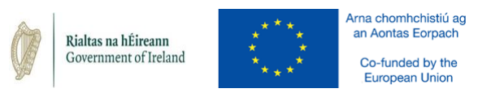

The Social Inclusion and Community Activation Programme (SICAP) is co-funded by the Government of Ireland, through the Department of Rural and Community Development, and the European Union.