 | Waterford Area Partnership CLG  wish to recruit a Community Connection Worker  (part-time 21 hours for 18-month contract)

Waterford Area Partnership CLG is a leading dynamic organisation developing creative and innovative responses in social inclusion across Waterford City & County. In developing local community responses, we seek to empower communities and individuals who experience social, economic and educational disadvantage in Waterford City and County by implementing person-centred programmes and activities supporting social inclusion, equality and lifelong learning through community development and collaborative practices.
Community Connection Project
The Community Connection Project (CCP) is a national initiative using community development and inclusion approaches to address the concerns of our local communities on integration, strengthening their existing work and experience to help build community resilience against misinformation and prejudice. The project will engage with the CCP National Coordinator with Local Development Companies Network to inform research, collate the multitude of approaches, challenges and other relevant information provided by workers across the country.
The Community Connection Worker (CCW) will work with local community organisations and key voluntary and statutory organisations and structures to develop creative methods to strengthen integration with a focus on establishing facts, counteracting misinformation and developing inclusive responses to migrant integration. Through community engagement in specific small geographic areas predominately in Waterford City with outreach to County areas, the worker will engage with residents in the area to provide intensive supports through creative approaches.
Role of the Community Connection Worker
The primary role of the Community Connection Worker is to work collaboratively with local community organisations and migrant community to enhance inclusion and integration in building sustainable approaches. Through creative approaches including outreach work the project will provide opportunities for dialogue, capturing the challenges and positive experiences at a local community level. In connecting with/meeting people where they live, we can actively respond to concerns, counter misinformation, organise activities, and share learning.
In participating with the national CCP Coordinator the development of the project and learning gained will inform policy decisions, develop toolkits and best practice models on positive community-led approaches to integration challenges that can be adapted for use within our local communities.
Our work is underpinned by community development principles & practices with equality, human rights and collaborative approaches.

Contract: 18-month contract for 21 hrs. per week. Six-month probationary period applies.

Location: Waterford Area Partnership city-based office with outreach work

Reporting to: Waterford Area Partnership’s Community Development Manager.
Key duties and responsibilities: the successful candidate will have the following responsibilities and duties.
- Work with local communities to strengthen community development practices and principles with equality, human rights and collaborative approaches
- Engage with local community organisations to acknowledge and document existing integration actions
- Identify challenges experienced by local communities due to migrant integration in their area e.g. dissemination of misinformation
- Agree key actions with collaborative partners to deliver practical responses as agreed and implement required resources
- Connect and meet with migrants to include International Protection Applicants in the areas where they live through outreach work to enhance community engagement with agreed actions
- Collate and disseminate information and resources for community organisations to strengthen their knowledge, resilience and capacity in integration and inclusion
- To organise a calendar of events and activities as agreed
- To provide reports and updates on activities as requested
- Document learning gained through the project to share with the LDCN National Coordinator and other partners to inform policy development, toolkit templates etc.
- To adhere to Waterford Area Partnerships policies and procedures
- To observe confidentiality both within the organisation and also with outside community organisations, agencies and individuals.

Undertake additional duties as may be required and/or requested by the Community Development Manager and/or CEO from time to time.

Community Connection Worker – Qualities Required

Person Specification
Essential criteria
- Third level degree desirable in community and social inclusion work either voluntary or professional.
and / or
- Minimum of 3 years’ practical experience as a volunteer or staff with community organisations, organising activities etc.
- Excellent verbal communication skills and person-centred approaches with emotional intelligence, respecting human rights, building trust through empathy and active listening.
- Excellent written communication skills in report writing, emails and collation of information.
- Proven experience of working from equality and human-rights focus using community development practices
- Practical leadership, group facilitation and coordination skills in delivering community-led actions, event planning, volunteer recruitment and mentoring and team building to support inclusion, integration and equality.
- Strong IT skills including Microsoft Office
- Strong practical time management skills with ability to prioritise and multi-task, meet deadlines and adhere to funding requirements.
- Adaptable approaches to new learning, reflective practice and critical thinking.
- Flexibility, with a willingness to travel and work outside normal office hours.

Desirable criteria
- Practical knowledge and awareness of local and national migrant policies, cultural sensitivities and migrant integration
- Awareness of the Irish International Protection system
- Experience in data analysis and policy writing.

Full driving license and access to own car is desirable but not essential for the position.

Salary is aligned with Waterford Area Partnerships Development Worker Scale (Pt 1 of €32,182 to Pt. 13 €51,980) pro rata of 21 hours and based on relevant experience.
To apply for the position please send your Curriculum Vitae and letter of application no later than Tuesday April 22nd at 2p.m. to: Catherine Power, Community Development Manager
Waterford Area Partnership CLG
1-2 Neptune House, Canada Street, Waterford.
or via email to info@wap.ie

Please note: Late applications will not be considered. Interviews will be held for successful applicants on Wednesday April 30th. The applicant who is offered the position must be available to commence in May

Candidates will be shortlisted based on the letter of application and Curriculum Vitae submitted which must be aligned with above criteria and must state your relevant experience, qualification and driver licence with access to own car.

Waterford Area Partnership CLG is an Equal Opportunities Employer

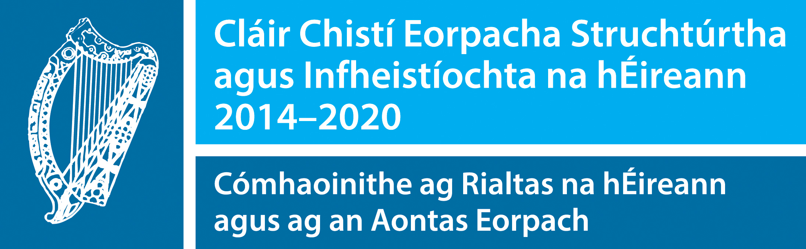 |  | 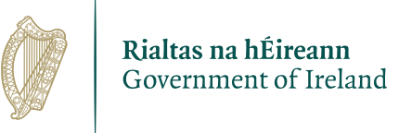 | 

