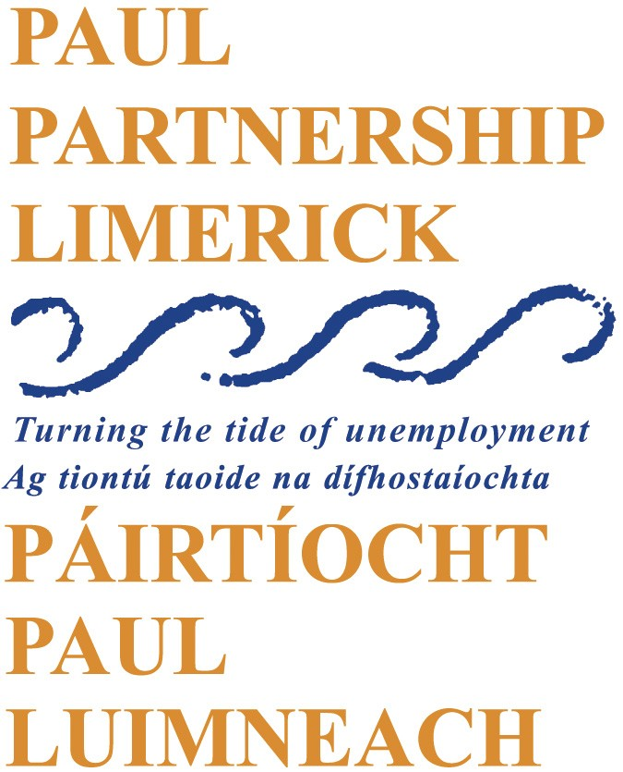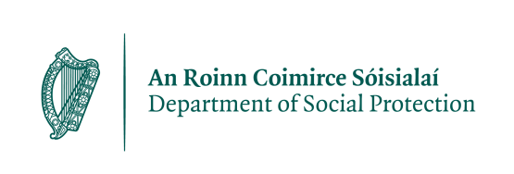

PAUL Partnership Limerick CLG

Mid West Local Area Employment Service Caseworkers - 12 Month Contract

Panel Formation

PAUL Partnership Limerick CLG is an organisation made up of communities, state agencies, social partners, voluntary groups and elected representatives. It works with communities that have benefited least from economic and social development and aims to promote social inclusion and improve the quality of life of people living in communities in Limerick City. PAUL Partnership delivers the LAES in the Mid West region – Limerick City and County, County Clare, and North Tipperary.

PAUL Partnership wishes to create a panel of suitably qualified people to fill current (2) and future Case Worker vacancies. The Caseworker works as part of a multi-disciplinary team to provide high quality one-to-one guidance, mediation, advice, job placement and aftercare service to those most distant from the labour market to enable them to progress to employment. Other progression routes are also explored to upskill job seekers, through education and training opportunities, in sectors where labour market demand exists.

This is a full time 12 months contract, 35 hours working week.
Salary scale is: €42,388 - €50,883 per annum.

Job Description and Application Form can be downloaded from the PAUL Partnership website: www.paulpartnership.ie

Only electronic application forms will be accepted. Completed application forms by e-mail to: recruitment@paulpartnership.ie

Closing date for applications is 5.00pm, Friday 28th March 2025.

PAUL IS AN EQUAL OPPORTUNITY EMPLOYER. CANVASSING WILL DISQUALIFY.
Shortlisting will apply.
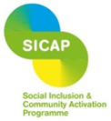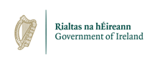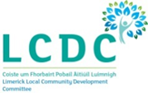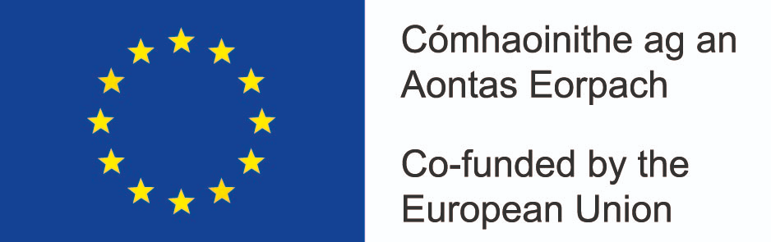
The Social Inclusion and Community Activation Programme (SICAP) is co-funded by the Government of Ireland, through the Department of Rural and Community Development, and the European Union.

