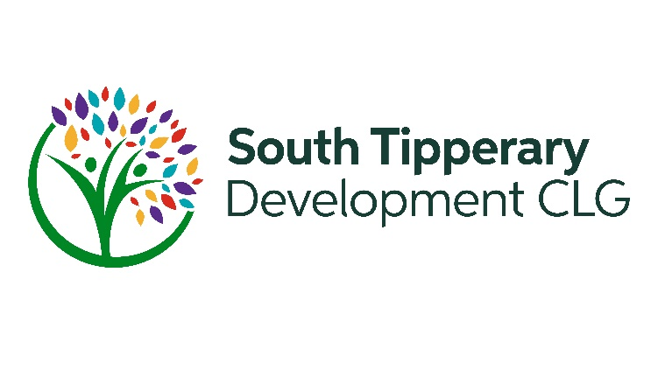

Job Title | JUST TRANSITION DEVELOPMENT OFFICER
Employer | South Tipperary Development CLG (STDC)
Reporting Relationship | Social Inclusion Programme Manager
Location of Post | Based in head office in Cahir. The post holder may work from our outreach offices from time to time.
Closing Date for Applications | 5 p.m. Friday February 28th 2025
Contract | 35 hours per week  Contract initially to December 31st 2025 with a possibility of extension to December 31st 2028
Benefits offered by STDC | Salary: Competitive salary in line with experience.  Travel expenses: Travel expenses are reimbursed at public service rates.  Annual Leave: 25 days in a calendar year  Pension: As per regulatory guidelines  Organisation Culture: Positive working environment and proactive approach to professional development, reflective practice and supervision.  Training & Development: Opportunities to access training relevant to the role.

South Tipperary Development Company (STDC) is a Community Led Local Development Company based in Cahir, Co. Tipperary. It is a not-for-profit registered charity and is overseen by a voluntary board of directors.
STDC is dedicated to creating positive change in our communities. Our work supports social inclusion, rural development, employment, enterprise and Just Transition across South Tipperary. Our key priorities as set out in our Strategic Plan are to: Strengthen Communities; Empower People; Protect the Environment; Work in partnership and collaboration with relevant stakeholders and to adopt innovative approaches to our work which will enable us to improve, grow and diversify the services we deliver. Programmes currently delivered by STDC include:
- Social Inclusion & Community Activation Programme (SICAP)
- LEADER Rural Development Programme
- Local Area Employment Services
- Tús – Labour Market Activation Programme
- Rural Social Scheme
- Traveller Primary Health Care Programme
- Outdoor Recreation & Walks Scheme

Role Overview
South Tipperary Development Company (STDC) is seeking a passionate and proactive Just Transition Development Officer to support communities in adopting sustainable practices while ensuring social inclusion and economic fairness. This role plays a key part in delivery of Pillar 3: Protect the Environment in STDC’s Strategic Plan. The successful candidate will primarily operate under the Social Inclusion and Community Activation Programme (SICAP) 2024-2028 but will provide supports to the Management Team and other programmes as required.

Key Responsibilities

1. Awareness & Capacity Building
- Develop and implement community awareness and capacity building initiatives to enhance understanding of climate change, sustainability, community resilience and Just Transition within target areas.
- Facilitate projects such as community gardens, allotments, community energy and circular economy initiatives leading to the development of local sustainability hubs.
- Support grassroots initiatives e.g. Men’s Sheds, Women’s Groups, Residents groups, community and youth organisations, etc in climate action efforts.

2. Fuel Poverty, Food Poverty & Economic Justice
- Raise awareness of the links between fuel poverty, food poverty and poor health.
- Provide guidance on affordable energy solutions to help vulnerable households reduce energy costs while maintaining a healthy living environment.
- Work with groups such as Healthy Ireland, Community Resource Centres, the Local Authority, to promote healthy sustainable living including positive nutrition, active travel, producing and consuming local produce, circular economy and a reduction in food waste.
- Advocate for government policies that prioritize low-income and marginalized groups in energy transition planning.

3. Wellbeing & Community Resilience
- Integrate mental and physical wellbeing into climate initiatives to support communities through economic and environmental shifts.
- Promote nature-based solutions, such as biodiversity projects and green spaces, to enhance wellbeing.
- Encourage uptake of green technology skills programmes amongst people in our social Inclusion target groups who are unemployed or working in sectors which are vulnerable to climate change.
- Work with local organisations to address climate anxiety and economic transition stress.

4. Project Implementation & Collaboration
- Co-operate with other organisations e.g. Sustainable Tipperary, Local Authority, Community Climate Coaches, TUS and others to promote and support a Just Transition for individuals, groups and areas designated disadvantaged.
- Link in with actions in the Just Transition area and Decarbonisation Zones within South Tipperary.
- Develop, coordinate and deliver sustainability-focused awareness events, exhibitions, and training sessions.
- Assist community organisation to embed climate action into their development plans, including supporting the SMART Sustainable Villages project.
- Encourage hands-on participation in sustainability projects and peer-to-peer learning.

5. Sustainability within STDC
- Support STDC staff in adopting sustainable workplace practices, including waste reduction and energy efficiency.
- Support STDC to develop their internal climate policy and action plan to reduce our Carbon footprint, enhance our Ecological Handprint and support biodiversity.
- Deliver internal training sessions to enhance staff engagement in Just Transition initiatives.
- Ensure STDC’s environmental actions is coherent with the Local Authority Climate Action Plan, the Local Economic and Community Plan and national climate policies.

Qualifications & Experience
Essential:
- Level 7 or higher qualification in Community Development, Rural Development, Social Science, Climate Change or a related field.
- Understanding of Just Transition as it relates to Community Development in a social inclusion context.
- 2-3 years’ experience in community development, ideally working with marginalised communities.
- Ability to develop strong positive relationships with a wide variety of stakeholders from marginalised communities to policy makers.
- Knowledge of community development principles, statutory and voluntary sector relationships, and climate action policies.
- Strong organisational, communication, and report-writing skills.
- Proficiency in Microsoft 365 and CRM systems.

Desirable:
- Experience working with marginalized communities affected by fuel poverty and economic hardship.
- Experience of working within government funded programmes, including reporting and grant management.
- Familiarity with local, national/EU Just Transition policies.

Other Requirements
- Full, clean driving licence and access to a vehicle for work.
- Commitment to the mission and values of STDC.
- Professional and ethical approach to work.
- Willingness to engage in training and occasional evening/weekend work.
- Ability to work as part of a team.

Terms of Employment
Full-time position - working 35 hours per week. Based in head office in Cahir, the post has a remit for all South Tipperary. The post offers a competitive salary in line with experience.
The contract is initially to December 31st 2025 but could be extended to Dec 31st 2028.

How to Apply

Send your CV together with a cover letter outlining your suitability for the post on offer.

Completed CVs should be sent to recruitment@stdc.ie

All applications should be marked JTDO post

Applications by email only and should be submitted no later than Friday, February 28th at
5 p.m.

Shortlisting may apply

Dates for interviews for this post have been provisionally set for 10th/11th March 2025.

STDC is an equal opportunities employer

