Donegal Local Development CLG
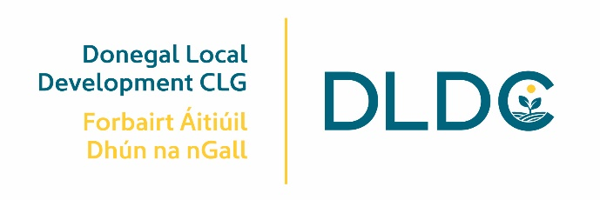

Rural Development Programme (RDP) Project Officer

Donegal Local Development CLG is an integrated local development company established in 1995. We deliver a number of external funded programmes to the Donegal community.

The RDP Project Officer will play a critical and central role within Donegal Local Development CLG (DLDC) through promoting innovative and strategic rural development via the resources of the LEADER Programme as well as integrating, where possible and relevant with the resources, actions and programmes administered by the company. A key focus is to animate the rural development programme in the Donegal catchment area to support and build capacity of rural communities and enterprises and to develop innovative projects.

The successful candidate will promote the Programme through stimulating projects, drawdown of funding, ensuring caseload management with financial and administration in compliance with the Rural Development Programme Ireland 2023– 2027 Operating Rules.

- The Project Officer will be required to work 35 hours per week
- A probationary period of at least six months will apply, and performance will be reviewed on an ongoing basis.
- This is a two-year Fixed Term contract until 31/12/2025, and may cease/continue after this date, dependent on funding.
- Main base will be Letterkenny.
To apply for the position, please submit by email, a Letter of Application together with current Curriculum Vitae and clearly outline how you meet the criteria to: HR Department at: vacancies@dldc.org

The closing date for receipt of Applications is 12 noon, Monday 27th November 2023 and no application will be accepted post deadline. Interviews are likely to take place on Thursday 30th November 2023.

Job Descriptions are available from vacancies@dldc.org and also on DLDC website www.dldc.org
We reserve the right to enhance the shortlisting criteria. A panel may be formed from which similar vacancies may be filled.

Donegal Local Development CLG is committed to a Policy of Equal Opportunity.
Canvassing will disqualify.
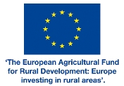
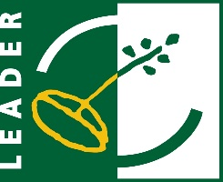
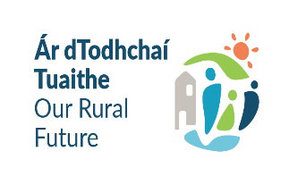
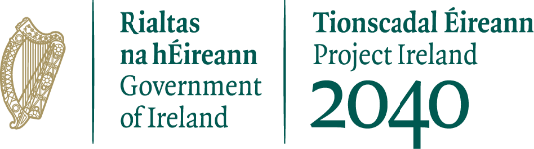
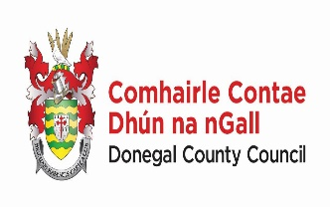
Funded by the Department of Rural & Community Development

