**Donegal Local Development CLG**

Donegal Local Development CLG is an integrated local development company established in 1995. We deliver a number of external funded programmes to the Donegal Community. Donegal Local Development CLG (DLDC) are now inviting applications for the following positions:

**HR Administrator**

We require an experienced HR Administrator to assist in the delivery of Human Resources functions for our team of 90 core staff members. The successful candidate will work alongside the HR Manager, contributing to the execution of operational HR activities covering all aspects of the employee lifecycle. Additionally, they will provide support for health and safety protocols and assist with internal staff communications.

* A relevant third level qualification in Human Resources or other related discipline
* Working knowledge of Employment Law in Ireland
* A minimum of 3 years’ experience working in a HR function
* The contract is of indeterminate duration and is subject to continued funding
* Main base will be Letterkenny

**Case Officer, Local Area Employment Services (LAES)**

The successful candidate will be required to work as a member of the LAES Team within DLDC to provide services to the long-term unemployed, under-employed and employers in Co. Donegal.

* A minimum of three years’ relevant experience working in the area of employment, enterprise and/or career guidance
* A well-grounded understanding of basic counselling and guidance concepts in the labour market sense
* This is a 2-year fixed-term contract subject to funding and client intake as set out by the Department
* We are creating a panel to fill roles as the need arises within the DLDC catchment area.

Job Description for both posts available from [**vacancies@dldc.org**](mailto:vacancies@dldc.org)and also on website[**www.dldc.org**](http://www.dldc.org)

**Application Process**

To apply for the position/s, **please submit by email a Letter of Application together with a current Curriculum Vitae** and **clearly outline how you meet the criteria to**: HR Department at: [**vacancies@dldc.org**](mailto:vacancies@dldc.org)

* The closing date for receipt of applications is **Tuesday 3rd October 2023** and no applications will be accepted post deadline
* Interviews are likely to take place on the week of **9th October 2023**.

We reserve the right to enhance the shortlisting criteria. A panel may be formed from which similar vacancies may be filled.

***Donegal Local Development CLG is committed to a Policy of Equal Opportunity.***

***Canvassing will disqualify.***

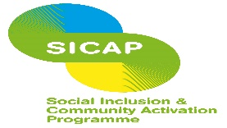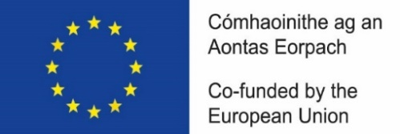

*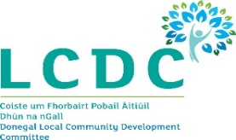

*“The Social Inclusion and Community Activation Programme (SICAP) is co-funded by the Irish Government, through the Department of Rural and Community Development, and the European Social Fund Plus under the Employment, Inclusion, Skills and Training (EIST) Programme 2021 -2027.”*