**Donegal Local Development CLG**

Donegal Local Development CLG is an integrated local development company established in 1995. We deliver a number of external funded programmes to the Donegal Community. Donegal Local Development CLG (DLDC) are now inviting applications for the position of **Project Officer, Life Long Learning** as part of its SICAP programme.

**Project Officer, Life Long Learning**

The Project Officer (Education & Training) will play a key role within the Goal 2 Life Long Learning team and will be required to implement the actions planned under Goal 2 of the Social Inclusion and Community Activation Programme as well as devising & delivering training/education programmes. They will be required to meet clients on a one-to-one basis and to create a supportive environment. The project officer will support clients who have experienced educational disadvantage to engage with lifelong learning opportunities and progress using community development approaches.

* The Project Officer will be required to work 35 hours a week.
* A probationary period of 6 months will apply.
* Performance in role will be discussed throughout the period of cover.
* This role is of fixed-term duration up to 31 December 2023 and may be extended subject to continuation of the SICAP programme and available funding.
* It is envisaged that the role will focus on serving clients in south of Co. Donegal.
* A recognized and relevant Third Level qualification **and / OR** a minimum of 3 years relevant training experience together with a proven track record in the delivery of training supports to adults is required.

Job Description is available from [vacancies@dldc.org](mailto:vacancies@dldc.org) and also on the DLDC website [www.dldc.org](http://www.dldc.org)

**Application Process**

To apply for the position, **please submit by email a Letter of Application together with a current Curriculum Vitae** and **clearly outline how you meet the criteria to**: HR Department at: [**vacancies@dldc.org**](mailto:vacancies@dldc.org)

* The closing date for receipt of applications is **Tuesday 12th September 2023** and no applications will be accepted post deadline
* Interviews are likely to take place on the week of **18th September 2023**.

We reserve the right to enhance the shortlisting criteria. A panel may be formed from which similar vacancies may be filled.

***Donegal Local Development CLG is committed to a Policy of Equal Opportunity.***

***Canvassing will disqualify.***

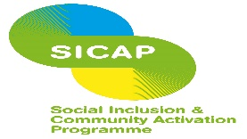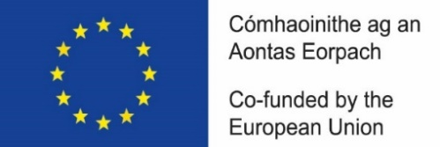****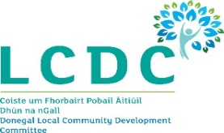***

*“The Social Inclusion and Community Activation Programme (SICAP) is co-funded by the Government of Ireland, through the Department of Rural and Community Development, and the European Union.*