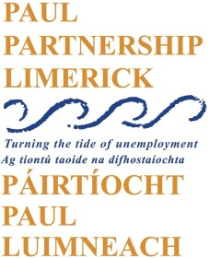

Community Employment Programme Supervisor – *Childcare Training and Development Programme*

PAUL Partnership has a vacancy for a full-time Community Employment Programme Supervisor (Childcare Training and Development Programme).

PAUL Partnership manages the Community Employment (CE) Childcare Training and Development Programme on behalf of the Department of Social Protection. The Programme is aimed at people interested in pursuing a career in childcare. It provides participants with the opportunity to gain a QQI Level 5 or 6 qualification in childcare whilst also gaining practical experience working in a childcare setting.

The role of the Supervisor isto coordinate the implementation of the Scheme in accordance with PAUL’s contract with the DSP. A core aspect of the role is to support and coach CE participants towards gaining the skills, competencies and qualifications in preparation for employment.

Job Description and Application Form can be downloaded from the PAUL Partnership website [www.paulpartnership.ie](http://www.paulpartnership.ie)

Only electronic applications will be accepted. Completed application forms by e-mail to [recruitment@paulpartnership.ie](mailto:recruitment@paulpartnership.ie)

**Closing date for applications is 5pm Thursday 3rd August**