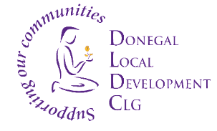

Donegal Local Development CLG
Donegal Local Development CLG is an integrated local development company established in 1995. We deliver a number of external funded programmes to the Donegal Community. Donegal Local Development CLG (DLDC) are now inviting applications for the position of Social Enterprise Officer as part of its SICAP 2021- 2027 programme. The post is full time, fixed term 4 to 6 months to support the delivery of the Social Enterprise programme of activity while the postholder fulfils an acting-up role.

The Social Enterprise Officer will support the development of Social Enterprise across the DLDC catchment area in Co. Donegal. They will support the development of the Social Enterprise Strategy for DLDC. The successful candidate will assist with the implementation of the actions planned under Goal 1 of the Social Inclusion and Community Activation Programme. They will be required to meet with Social Enterprises to provide advice, guidance, development supports, mentoring and facilitation as required.
- The Social Enterprise Officer will be required to work 35 hours a week.
- This role is subject to funding. Main base will be Letterkenny
- The successful candidate shall hold a recognised Third Level qualification in Business Management / Community Development and /OR A minimum of three years’ relevant work experience in the area of Community Development with demonstrable detailed knowledge and experience of social enterprise.
Job Description is available from vacancies@dldc.org and also on the DLDC website www.dldc.org

Application Process

To apply for the position, please submit by email a Letter of Application together with a current Curriculum Vitae and clearly outline how you meet the criteria to: HR Department at: vacancies@dldc.org
- The closing date for receipt of applications is Tuesday 6th June 2023 and no applications will be accepted post deadline
- Interviews are likely to take place on the week of 12th June 2023.

We reserve the right to enhance the shortlisting criteria. A panel may be formed from which similar vacancies may be filled.
Donegal Local Development CLG is committed to a Policy of Equal Opportunity.
Canvassing will disqualify.
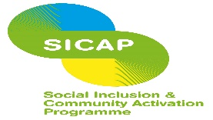
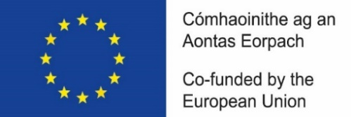

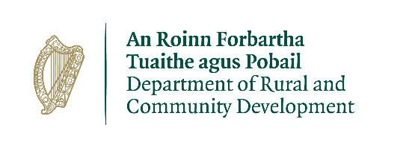
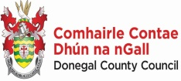
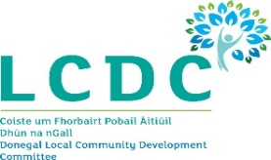

“The Social Inclusion and Community Activation Programme (SICAP) is co-funded by the Government of Ireland, through the Department of Rural and Community Development, and the European Union.

