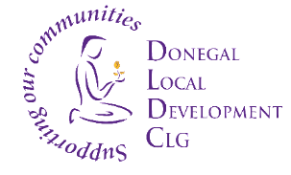
Donegal Local Development CLG

Donegal Local Development CLG is an integrated local development company established in 1995. We deliver a number of external funded programmes to the Donegal Community. DLDC aims to work with people displaced from Ukraine who have come to Donegal seeking safety because of the war in Ukraine. We work to identify and address their support needs as well as organise events, community activities and opportunities to support wider community integration. Donegal Local Development CLG (DLDC) are now inviting applications for the following positions:

Health Support Officer
The Health Support Officer will support and empower individuals and the community to build their capacities for the enhancement and improvement of the health & wellbeing and integration into the community.
The Officer will be required to work 35 hours a week. This contract term is of fixed term duration up to 31st December 2023 and is subject to funding. The Officer shall have an appropriate third level qualification in the area of health promotion e.g. mental health or substance misuse or in a related area and 1 year experience in implementing programmes in community and/or health settings, Or; 2 years relevant experience in a health project and supporting health behaviour changes.

Part-Time Community Transport Drivers x 2
DLDC is seeking to two part time drivers based in Gweedore, required to work 17.5 hours per week each. The successful candidates will have the ability to communicate with individuals and service transport requests in line with a prioritised schedule. Requirement as per below:
- Full Clean Category D – (Bus) Driving Licence with no penalty points, accidents/claims or convictions.
- Applicants must be eligible to drive in Ireland and must hold an updated Certificate of Professional Competence (CPC), this is a valid qualification required for certain professional drivers in Ireland.
- Postholders will be required to drive leased vehicles from leasing companies that require drivers to be over the age of 25.

Job Descriptions are available from vacancies@dldc.org and also on the DLDC website www.dldc.org

To apply for any of the above position/s, please submit by email a Letter of Application clearly outlining how you meet the criteria, together with current Curriculum Vitae to: HR Department, at: vacancies@dldc.org

Applications to arrive no later than 5pm, Friday 2nd June 2023 and no applications will be accepted post deadline. Applicants who demonstrate how they meet the required criteria will be invited to a competency-based selection interview on the week of 5th June 2023. We reserve the right to enhance the shortlisting criteria. A panel may be formed from which similar vacancies may be filled.
Donegal Local Development CLG is committed to a Policy of Equal Opportunity.
Canvassing will disqualify.
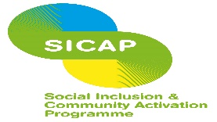
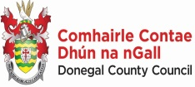
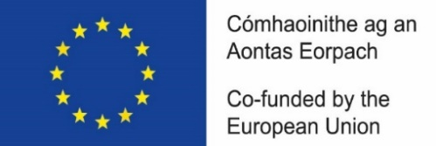

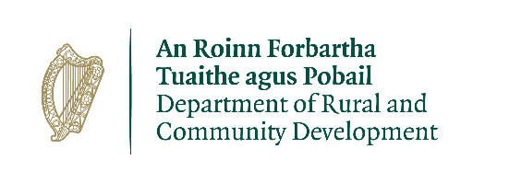
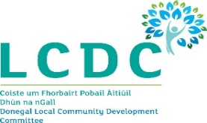

“The Social Inclusion and Community Activation Programme (SICAP) is co-funded by the Government of Ireland, through the Department of Rural and Community Development, and the European Union.

