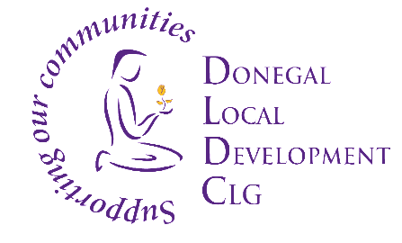
Donegal Local Development CLG

Donegal Local Development CLG is an integrated local development company established in 1995. We deliver a number of external funded programmes to the Donegal Community. DLDC aims to work with people displaced from Ukraine who have come to Donegal seeking safety because of the war in Ukraine, and those who have come here seeking International Protection (IP). We work to identify and address their support needs as well as organise events, community activities and opportunities to support wider community integration. Donegal Local Development CLG (DLDC) are now inviting applications for the following positions:

- New Communities Project Coordinator
The successful candidate will have the ability to communicate with individuals and facilitate groups, liaise with agencies and stakeholders and have the ability to work on own initiative and as part of a team. He/ She will manage a team of community links/support workers and work effectively and collaboratively as part of a wider team. Engage with New Communities in Donegal and a wide range of service providers using an integrated and community development approach to address issues relating to social exclusion and inequality.

- Vehicle Administration Coordinator
The successful candidate will oversee the effective management of community vehicles, including coordinating a team of Support Workers/Drivers. They will work collaboratively as part of a wider team and effectively coordinate resources to provide transport solutions to target groups to access services.

- Project Officer – Learning, Development & Inclusion
The Project Officer will have a key role in coordinating learning, development, inclusion and education programmes for New Community target groups, with a specific focus on supporting people displaced from Ukraine.

Job Descriptions are available from vacancies@dldc.org and also on the DLDC website www.dldc.org

To apply for any of the above position, please submit by email a Letter of Application together with current Curriculum Vitae to: HR Department, Donegal Local Development CLG, Unit 1, 2nd Floor, Glenview Business Park, Carnamuggagh Upper, Letterkenny, Co. Donegal to: vacancies@dldc.org

Applications to arrive no later than Thursday 9th February 2023. Interviews are likely to take place week beginning 13th February 2023. We reserve the right to enhance the shortlisting criteria. A panel may be formed from which similar vacancies may be filled.

Donegal Local Development CLG is committed to a Policy of Equal Opportunity.
Canvassing will disqualify.
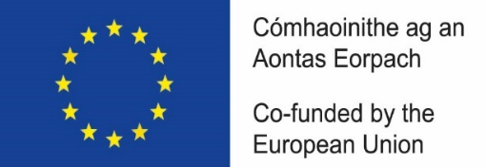
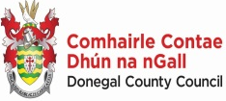
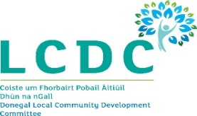
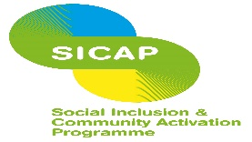

“The Social Inclusion and Community Activation Programme (SICAP) 2018-2022 is funded by the Irish Government through the Department of Rural and Community Development and co-funded by the European Social Fund under the Programme for Employability, Inclusion and Learning (PEIL) 2014-2020”

