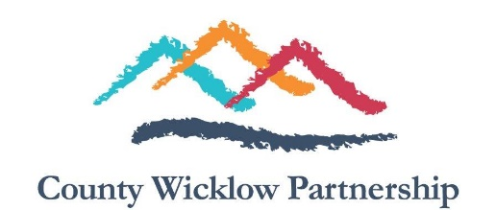
Employment Opportunity
East Coast Regional Drugs & Alcohol Task Force - Development Worker
County Wicklow Community Partnership CLG (CWP) is a Local Development Company that delivers a range of social inclusion, enterprise, employment and community development programmes for individuals and communities in County Wicklow.
County Wicklow Partnership is the current awardee of a tender to host, support and line manage a Development Worker on behalf of the East Coast Regional Drug and Alcohol Task Force (ECRDATF).

The Development Worker will play a pivotal role in supporting the ECRDATF fulfilling the aims and objectives as outlined in its current and future Strategic Plans and in line with the actions identified in the National Drugs Strategy (Reducing Harm Supporting Recovery 2017-2025).

The successful candidate will have:
- A relevant third level qualification in community development, addiction studies, social work or a related discipline. (minimum NQF level 7)
- At least 3 years’ experience in Community Development Work or similar role.
- Excellent facilitation, presentation and organisational skills.
- Experience in writing clear and precise reports.
- An in-depth understanding of social inclusion and its application through community development principles and practice.
- The proven ability to carry out a community needs analysis.
- Be highly motivated, with the ability to work independently in a team setting.
- Identify initiatives, and support communities/groups to manage and progress them.
The Development Worker will be employed in a full time capacity (35 hours per week, reduced hours negotiable) for an initial twelve month period with a role impact and delivery review to take place at six months (probationary period). Garda Vetting and referencing checks will be required before employment commences. Remuneration will be commensurate with qualifications and experience. May suit recently/semi-retired worker with the appropriate qualifications and experience. Short-listing of candidates may apply. A panel may be formed from which future positions may be filled.
Applications by email only to:
Email recruitment@wicklowpartnership.ie for an application form and job description. Closing date for receipt of completed applications is Monday, 12 December 2022.

Canvassing in any form will disqualify
County Wicklow Partnership is an equal opportunities employer
