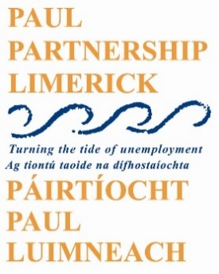

PAUL Partnership Limerick CLG
Chief Executive Officer

Established in 1989, PAUL Partnership Limerick CLG is the Local Development Company for Limerick City. It is an organization made up of communities, state agencies, social partners, voluntary groups, and elected representatives. It works with communities that have benefited least from social and economic development and aims to promote social inclusion and improve the quality of life of people living in communities in Limerick City. With an annual budget in excess of €5m, the company delivers a range of publicly funded programmes, enables the management of complex strategic collaborations, and contributes to the development of policies which aim to address social exclusion. Current programmes include:
- Social inclusion Community Activation Programme
- Mid West Local Area Employment Service
- ABC Startright
- TUS
- Community Employment
- Healthy Communities
- Empowering Communities
Reporting directly to the Chairperson and the board, the Chief Executive Officer will be responsible for delivering the mission of the company and will oversee the development and implementation of all company strategies, programmes and actions. He/she will be responsible for ensuring best practice in overall company governance and management, including programmes and people management, administration and finance.
The person appointed will need:
- A relevant 3rd level qualification at level 8 or higher
- A minimum of 5 years management experience in a similar sized organization
- Experience of planning, procuring, and implementing large scale projects
- Experience of working in Multi Agency Collaborations
The appointment will be full-time, 5 days per week, on a 6-point salary scale - €77,483 to €94,550 per annum.
A job description and application form can be downloaded from the Jobs/Vacancies section of the PAUL Partnership website www.paulpartnership.ie
Only completed application forms returned via email will be accepted and should be submitted to recruitment@paulpartnership.ie
Closing date for receipt of application is 5.00pm on Wednesday 23rd November 2022.

Shortlisting will apply. PAUL Partnership Limerick CLG is an equal opportunities employer.
Canvassing will disqualify.
