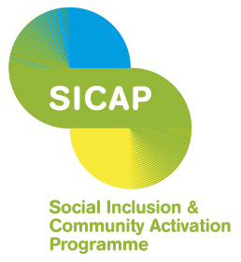

PAUL Partnership Limerick CLG
Financial Controller

PAUL Partnership Limerick CLG is an organisation made up of communities, state agencies, social partners, voluntary groups and elected representatives. It works with communities that have benefitted least from economic and social development and aims to promote social inclusion and improve the quality of life of people living in communities in Limerick City. The Partnership now wishes to make an appointment to its Senior Management Team.
The Financial Controller plays a key role within the management structure of PAUL Partnership and is responsible for managing the finance function of the organisation.
The person appointed will need:
- Recognised Professional Accountancy Qualification
- Minimum of 5 years’ experience in a senior finance role
- The ability to think and plan strategically and to motivate and support staff to achieve results
- Excellent communication and interpersonal skills
- Experience of managing governance and other regulatory compliance.
The appointment will be full-time, 5 days per week, and the commencing salary of a 6-point scale is €53,465.00 per annum. A job description and application form can be downloaded from the Jobs/Vacancies section of the PAUL Partnership website www.paulpartnership.ie
Closing date for receipt of application is 5.00pm on Monday 15th August 2022.
Only completed application forms returned via email will be accepted and should be submitted to recruitment@paulpartnership.ie A panel may be formed from which future vacancies may be filled.

Shortlisting will apply. PAUL Partnership Limerick CLG is an equal opportunities employer.
Canvassing will disqualify.

