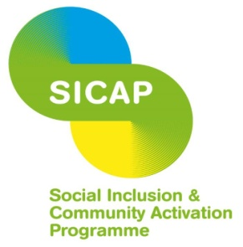

RESEARCH AND EVALUATION OFFICER – SOCIAL INCLUSION AND COMMUNITY ACTIVATION PROGRAMME (SICAP)

Responsibilities:

The Research and Evaluation Officer will be responsible for:
- Developing and operating CCP’s internal SICAP performance management systems in conjunction with the CEO and Programme Co-ordinator.
- Coordinating the development of CCP’s annual planning, mid and end of year reviews and writing-up of reports as required.
- Preparation of required programme returns to the LCDC and Pobal.
- Undertaking socio-economic and demographic analyses of Cork City and specific areas of disadvantage.
- Preparation of qualitative case studies to demonstrate the effectiveness of actions and interventions.
- Carrying out relevant research and evaluation activities with diverse groups using a range of tools such as focus groups.
- Providing expertise to SICAP colleagues and work with them to undertake evaluations of local actions.
- Providing support to local community groups requiring information and assistance in relation to research and evaluation.
- Liaising with other Local Development Companies (LDCs) on research and evaluation work being carried out by CCP in conjunction with other LDCs or the Irish Local Development Network (ILDN).
- Preparation of a quarterly CCP information/news bulletin.
- Representing CCP in relevant external structures.
- Carrying out other relevant tasks assigned from time to time by the CEO or Programme Co-ordinator.
The above duties and responsibilities are not intended to be a complete list of all duties involved and consequently, the post holder may be required to perform other duties as appropriate to the post which may be assigned to him/her from time to time and to contribute to the development of the post while in office.
The post-holder must be available to work evenings as necessary.
Experience/skills required
- QQI Level 8 in a relevant third level qualification.
- Knowledge of Census Small Area Population Statistics SAPMAP Interactive Mapping Tool, Pobal Maps, Pobal HP Deprivation Index.
- Knowledge of socio-economic and demographic trends in Cork City and nationally.
- Excellent organisational skills, including the capacity to manage complex tasks, work independently and work to deadlines.
- Strong IT skills, in particular knowledge of research IT tools such as SPSS, NVivo, Survey Monkey etc. and the ability to present data in a range of formats and to various audiences.
- At least 3 years research experience, including census profiling, policy and literature review, data collection and collation, research report writing.
- Experience of facilitating consultation and feedback sessions with diverse groups.
- Experience of writing documents, in an accessible format, to publication standard.
- Experience of training delivery and support.
- Excellent verbal and written communication skills
- Car owner with full driver’s licence
Location Cork City
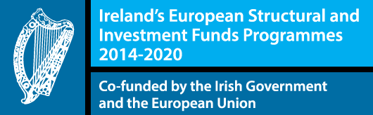
Contract duration To end of 2023. A 6-month probationary period will apply.

The Social Inclusion and Community Activation Programme (SICAP) 2018-2022 is funded by the Irish Government through the Department of Rural and Community Development and co-funded by the European Social Fund under the Programme for Employability, Inclusion and Learning (PEIL) 2014-2020.

