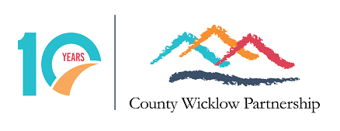

Employment Opportunity
Social Inclusion Manager Maternity Leave Cover
Full time 35 hours per week, 12 month contract

County Wicklow Community Partnership CLG is a Local Development Company that delivers a range of social inclusion, enterprise, employment and community development programmes for individuals and communities in County Wicklow.
County Wicklow Partnership has been awarded the contract to deliver the Social Inclusion and Community Activation Programme (SICAP) 2018-2023 by the Wicklow Local Community Development Committee for the municipal districts of Baltinglass, Wicklow and Arklow. SICAP 2018-2023 aims to reduce poverty and promote social inclusion and equality in Ireland through supporting communities and individuals using community development approaches, engagement and collaboration.
To this end, County Wicklow Partnership wishes to appoint a Social Inclusion Manager for a Maternity Leave Cover position. Working 35 hours per week the role will involve the coordination of the Social Inclusion and Community Activation Programme (SICAP) 2018-2023 for the Municipal Districts of Arklow, Baltinglass and Wicklow from mid July 2022 for a 12-month duration (exact dates to be confirmed with the successful candidate). The workload will include the line management of the County Wicklow Partnership SICAP team and line management of the staff member hosted by the East Coast Regional Drugs and Alcohol Taskforce, overseeing and managing the SICAP annual plan targets and programme key performance indicators to ensure annual programme targets are met, liaise with our funders and adhere to all reporting and auditing requests, manage the programme budgets, participate in various committee’s and interagency meetings to ensure the SICAP annual plan and outcomes are achieved and work alongside the SICAP team to develop the submission for the successor SICAP programme. A full job description is attached.
Application by completion and submission of CWP application form accompanied by a cover letter. Application forms can be downloaded from our website (News section) or requested by emailing recruitment@wicklowpartnership.ie. A Curriculum Vitae will not be accepted as a valid application. Only applications made on the official form will be considered.

Please mark the envelope ‘Private & Confidential, Social Inclusion Manager Maternity Leave Position, CEO, County Wicklow Partnership, 3rd Floor, Avoca River House, Bridgewater Centre, Arklow, Co. Wicklow or email to recruitment@wicklowpartnership.ie. The closing date for receipt of applications is not later than 5p.m. on Tuesday the 14th June 2022. Interviews will take place on the week of 20th of June.

