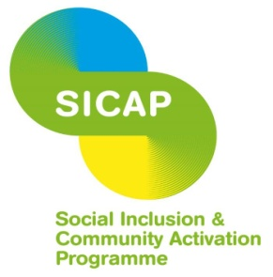

FRIENDLY CALL CORK DEVELOPMENT SUPPORT WORKER – SOCIAL INCLUSION AND COMMUNITY ACTIVATION PROGRAMME

Responsibilities:

The Friendly Call Development Support Worker will be responsible for:
Volunteer Supports
- Working with the Friendly Call Development Worker to recruit volunteers.
- Developing new protocols for monitoring and supporting volunteers remotely.
- Providing ongoing support to volunteers, including peer connection.
- Developing and implementing a debriefing system for volunteers.
- Establishing volunteer meetings to support shared learning and networking.
- Arranging and/or delivering ongoing training for volunteers.
- Providing a secondary contact point through which volunteers can arrange referrals for clients in the absence of the Friendly Call Development Worker.
- Liaising with the Cork Volunteer Centre as directed.
Client Supports
- Making calls as necessary to ensure service capacity is maintained.
- Raising awareness of places to signpost clients among new volunteers through compiling a resource directory.
IT/Admin Supports
- Provision of ACORN tablets to Friendly Call clients, to include meeting the older person, setting up the devices and delivery of training on how to use them.
- Carrying out administrative tasks, including responsibility for maintaining records of ACORN distribution and central Friendly Call databases.
- Provide administrative support to the Friendly Call Development Worker as required.
- Provide office reception cover as required.
The above duties and responsibilities are not intended to be a complete list of all duties involved and consequently, the post holder may be required to perform other duties as appropriate to the post which may be assigned to him/her from time to time and to contribute to the development of the post while in office.
Experience/skills required
Relevant qualification.

At least 2 years relevant administrative work experience.

Excellent communication skills (written and interpersonal).
Be able to demonstrate ability to engage with older people and with volunteers.
Be self-motivated, flexible and able to work on own initiative.
Good organisational and administrative skills (e.g., record keeping and ability to work to deadlines).
Have a good level of I.T. skills, knowledge of ACORN tablets is desirable.
Car owner with full driver’s licence.
Location Churchfield, Cork City
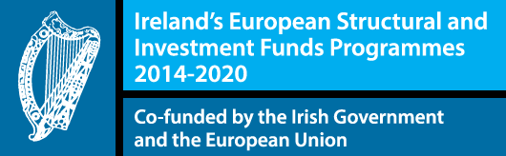
Contract duration To December 2023. A 6-month probationary period will apply.

The Social Inclusion and Community Activation Programme (SICAP) 2018-2022 is funded by the Irish Government through the Department of Rural and Community Development and co-funded by theEuropean Social Fund under the Programme for Employability, Inclusion and Learning (PEIL) 2014-2020.

