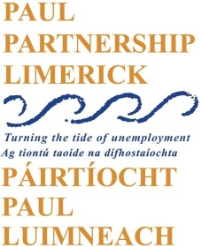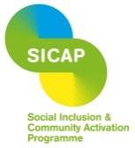

Social Inclusion and Community Activation Programme (SICAP)

Vacancy

SICAP Client Support Worker
A vacancy has arisen for a fulltime (35 hours per week) SICAP Client Support Worker supporting PAUL Partnership’s activities in providing individual support to people living in very and extremely disadvantaged communities who are the hardest to reach and often lack capacity to benefit from the current mainstream services. The overall purpose of the role will be to deliver an holistic one-to-one caseload service to individuals currently experiencing social exclusion in Limerick City.

This is a full time contract. SICAP will run up to December 2023.
Job Description and Application Form can be downloaded from the PAUL Partnership website: www.paulpartnership.ie
Only electronic application forms will be accepted. Completed application forms by e-mail to recruitment@paulpartnership.ie

Closing date for applications is 5.00pm Friday 28th January 2022.

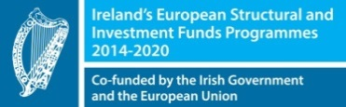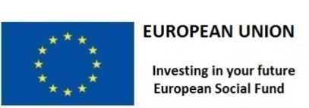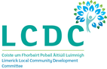
The Social Inclusion and Community Activation Programme (SICAP) 2018-2022 is funded by the Irish Government through the Department of Rural and Community Development and co-funded by the European Social Fund under the Programme for Employability, Inclusion and Learning (PEIL) 2014-2020.

