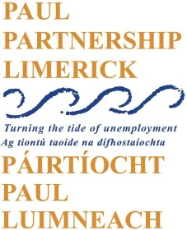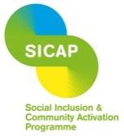

Social Inclusion and Community Activation Programme (SICAP)

Vacancies

SICAP Traveller and Roma Support Officer
A vacancy has arisen for a part-time (17.5 hours per week) Traveller and Roma Support Officer to support the delivery of community outreach initiatives, and group and individual development supports with the Traveller and Roma Communities in Limerick City.

SICAP Community Development Officer
A vacancy has arisen for a part-time (17.5 hours per week) Community Development Officer supporting PAUL Partnership’s activities in providing community development support for local groups and communities. The overall purpose of the role will be to support the delivery of a range of well-organised, imaginative, quality projects and capacity building supports for community groups. This is a temporary contract to cover staff leave of absence. A contract will be offered to the end of September 2022.

Only electronic application forms will be accepted. Completed application forms by e-mail to recruitment@paulpartnership.ie

Closing date for applications is 5.00pm Wednesday 6th October 2021

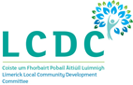
The Social Inclusion and Community Activation Programme (SICAP) 2018-2022 is funded by the Irish Government through the Department of Rural and Community Development and co-funded by the European Social Fund under the Programme for Employability, Inclusion and Learning (PEIL) 2014-2020.

