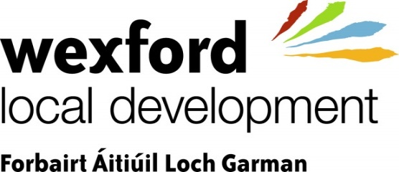

Wexford Local Development is inviting applications for a number of full-time positions as:
Community Development & Outreach Project Officers

Wexford Local Development’s mission is to create opportunities that promote equality and improve quality of life for people and communities.

Our vision is thriving, resilient communities where people feel connected, are valued and have equal opportunity to reach their full potential

We currently have exciting opportunities for self-motivated people to work with us in the role of Community Development & Outreach Officers.

The position holder(s) will be responsible for implementing a range of programmes and actions under the Social Inclusion and Community Activation Programme. The positions are being offered on full-time basis but will be subject to continued government funding. The Community Development and Outreach Officers will work as part of WLD’s county-wide Community Development team.
Applicants for this position will be required to have;

- A minimum qualification of NFQ Level 7 or 8 in a relevant field including but not exclusively community development
- A minimum of 2 years relevant experience working in a relevant professional field with community organisations or projects & direct experience of working with marginalised individuals and communities
- Access to transport and a full clean driving licence as travelling and outreach work will be an essential part of the job

Job description available on https://www.wld.ie/careers-2/
Please e-mail your CV and letter of application marked Community Development Officer to hr@wld.ie

Closing date for receipt of applications is Wednesday, September 29th, 2021

Wexford Local Development LTD is an equal opportunities employer CANVASSING WILL DISQUALIFY

