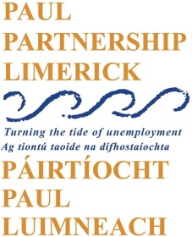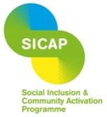

Social Inclusion and Community Activation Programme (SICAP)

Vacancy

SICAP Community Development Officer
A vacancy has arisen for a part-time (21 hours per week) Community Development Officer supporting PAUL Partnership’s activities in providing community development support for local groups and communities. The overall purpose of the role will be to support the delivery of a range of well-organised, imaginative, quality projects and capacity building supports for community groups. A key part of this role will be to support community engagement and group development with the Limerick City Traveller Community.
This is a temporary contract to cover staff leave of absence. A contract will be offered to the end of September 2022.
Job Description and Application Form can be downloaded from the PAUL Partnership website: www.paulpartnership.ie
Only electronic applications will be accepted. Completed application forms by e-mail to recruitment@paulpartnership.ie

Closing date for applications is 5.00pm Tuesday 3rd August 2021
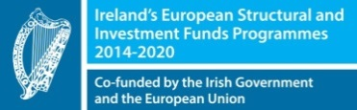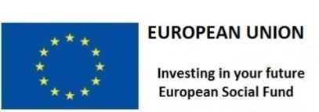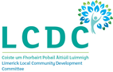
The Social Inclusion and Community Activation Programme (SICAP) 2018-2022 is funded by the Irish Government through the Department of Rural and Community Development and co-funded by the European Social Fund under the Programme for Employability, Inclusion and Learning (PEIL) 2014-2020.

