Job Vacancies

Donegal Local Development CLG is an integrated local development company established in 1995. We deliver a number of external funded programmes to the Donegal community.

In conjunction with our partners Donegal Intercultural Platform & Donegal Travellers Project, we will be delivering our newest project the key focus of which will be working towards inclusivity for the Black, Minority and Ethnic (BME) Communities including Travellers & Roma across Donegal. The project will seek to build dynamic relationships at an individual and societal level which will be based on understanding, acceptance, trust, respect and equality.

We are now inviting urgent applications for the following new positions:

- Equality Officer/Project Manager – 24 hours per week – Salary €24k
- Community Links Worker – 24 hours per week – Salary €19.8k

These positions are funded for a period of 3 years which may be extended or reduced subject to continuation of funding. Working pattern for both roles will be 24 hours per week, the rostering of which will be agreed.

- The Equality Officer will co-ordinate and oversee the development of the project and will line manage the Community Links Workers and relevant others. It is essential that you have a third level qualification in Community Development/Social Inclusion/Equality/Diversity or related field. It is also essential that you have a minimum of 2 years’ experience working with and for BME communities, which must be current. It is essential that you have current people management experience.

- The Community Links Worker will build meaningful relationships with BME communities including Traveller and Roma. It is essential that you have a recognised qualification in Community Development/Social Inclusion/Equality/Diversity or related field. It is also essential that you have a minimum of 2 years’ current experience working with and for individuals or communities who experience inequality. It is essential that you have a proven track record in delivering programmes and projects.

These roles are expected to be based in Letterkenny, however flexibility may be possible with regards to location. You should have a clean driving license and access to your own car for travel.

To apply for the position, please submit by email, a Letter of Application together with current Curriculum Vitae to: HR Department, Donegal Local Development CLG , 1 Millennium Court, Pearse Road, Letterkenny, Co. Donegal to: vacancies@dldc.org

Applications to arrive no later than 12 Noon on Friday 30th April 2021.

Job Descriptions for both roles are available from vacancies@dldc.org and also on DLDC website www.dldc.org
Partnership panel interviews will be held on Thursday 13th May 2021. We reserve the right to enhance both the essential and desirable shortlisting criteria, dependent on response. A panel may be formed from which similar vacancies may be filled.

Donegal Local Development CLG is committed to a Policy of Equal Opportunity. Canvassing will disqualify.
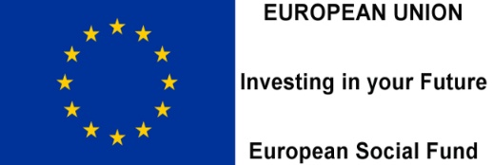
Funded by the Department of Rural and Community Development.

