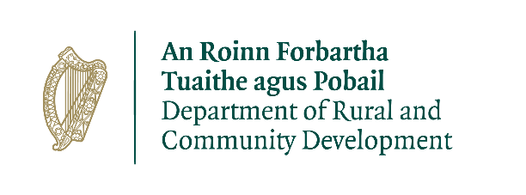

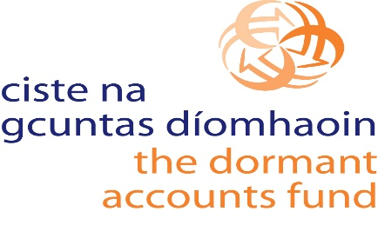

COVID-19 Social Enterprise Regeneration Programme 2021

APPLICATION FORM
February 2021

CLOSING DATE AND TIME FOR APPLICATIONS IS
26th March 2021 AT 12:30 PM

APPLICATION FORM – USEFUL INFORMATION
This form is only to be used for applications to the Covid-19 Social Enterprise Regeneration Programme 2021. The programme is being administered by the Irish Local Development Network (ILDN) on behalf of the Department of Rural and Community Development (DRCD).

The scheme, which is funded by the Dormant Accounts Fund (DAF), will provide grants of up to €80k to provide free training and mentoring to social enterprise managers, directors and staff across the country, with a focus on strategic planning, digital innovation, capacity building and governance.

It will assist social enterprises to strengthen their operations, to repurpose or diversify their trading income while living in a COVID-19 operating environment.
Before you fill in your application:

- Save a copy of the application form to your own computer as a Word Document - please do not PDF the final completed form.

- The questions in the application form have a maximum character limit imposed for your response and this is illustrated by the size of the textbox for each question i.e. the text box size indicates the maximum amount of information that you can include in your response.

- Please note: only the information that is visible within a textbox will be taken into account when appraising your application.

- Read the application guidelines. These guidelines describe who can apply, what actions and costs are eligible and how we will appraise your application.
The guidelines are available on the following website:

- ILDN Website: www.ildn.ie

Any Questions
If you have any questions in relation to “COVID-19 Regeneration Scheme for Social Enterprises”, please contact a member of our team.

E-mail: socialenterprise@ildn.ie
Tel: 061 404923

Section 1: Your Organisation and Contact Details
- What is the name of your organisation? This is the name shown on your governing documents.
Click or tap here to enter text.

- What is the address of your organisation?
Address | Street1
 | Street2
 | Street3
Town/City | Town/City
County | Select County
EIRCODE  (To find your Eircode go to: www.eircode.ie) | Eircode

- Your Contacts
We need some personal information for two different people in your organisation involved in your application.
- A main contact i.e. the person we can contact on behalf of your organisation in relation to this application.
- Chairperson or Chief Executive Officer’s contact details i.e. the person legally responsible and accountable for this application and any subsequent grant agreements (contract).

Main Contact
Name | First Name & Last Name
Role/Job Title | Role/Job Title
E-mail | Email
Telephone | Landline
 | Mobile
CEO or Chairperson
First Name & Last Name
Role/Job Title
Email
Landline
Mobile

- Consortium/Partnership
Please provide the following information and include all partners.
Name of Partner Organisation(s)
Click or tap here to enter text.
Partner(s) Role(s) in the implementation and delivery of the project.
Click or tap here to enter text.

Section 2: Details of your Proposed Project
- Provide a title for your project
Click or tap here to enter text.

- What is the proposed start date and end date for your project?
Note: The earliest start date for your project will be 1st April 2021 and the final day for projects will be the 5th November 2021. Your project can start or finish any time between these dates. (Final date for reimbursement is 12th November)
Start Date | Click to enter a date not earlier than 01/04/2021.
End Date | Click to enter a date not later than 5/11/2021.

- Describe your project. In your description please explain how the project will provide supports to social enterprises.
Click or tap here to enter text.

- Describe how the project meets the aims and objectives of this grant programme? Refer to the applicant guidelines for the programmes aims and objectives and key criteria in your response.
Click or tap here to enter text.
- Outline how you intend to monitor progress to ensure that the project will be delivered within your proposed timelines.
Click or tap here to enter text.

Section 3: Finances
- What is the total cost of your project?
Enter whole number only–no decimals.
Click or tap here to enter text.

- What is the grant amount you are seeking from this programme?
Enter whole number only–no decimals.

Click or tap here to enter text.

- If the total cost is greater than the grant amount requested, please provide an explanation on how these additional costs will be met by your organisation.
Click or tap here to enter text.

- Please complete the budget table below.
Ensure that you read the application guidelines in advance. The application guidelines provides you with information on eligible and ineligible costs and the information on the level of detail we require.
PROJECT BUDGET
Project Cost | Cost (€) | Refer to the eligible costs outlined in the application guidelines.  Provide a detailed explanation and justification for each cost applied for.
Direct Project Costs
Subtotal Direct Project Costs
Direct Employment Costs
(if applicable)
Subtotal Direct Employment Costs
Total Project Costs

Any other relevant information to support your application?
You may include any further information to support your application in the following two pages. Please clearly indicate which question in the application form the information corresponds to.
Click or tap here to enter text.

Application Submission

Please read carefully:

By submitting the application, the Board of Directors/Management Board declare that the information provided in relation to the organisation described in this application is true and complete to the best of their knowledge and belief.

The Board of Directors/Management Board acknowledges that any funds awarded must be used for the purpose stated and not used to replace existing funding. The Board also understands that information supplied in, or accompanying, this application may be made available on request under the Freedom of Information Acts 2014.

The Board accepts, as a condition of the award of a grant, that it involves no commitment to any other grants from The Department of Rural and Community Development (DRCD) or ILDN. The Board are agreeable to having the project monitored by ILDN and DRCD and to allow access to premises and records, as necessary, for that purpose.

The Board of Directors/Management Board also accepts that ILDN may contact other Funder Organisations or Government Departments to discuss this application and previous funding awarded, as part of the appraisal process.

The Board of Directors/Management Board it will be a condition of the awarding of any funds that any project funded will be in compliance COVID-19 public health guidelines.

It will be a condition of any application for funding under the terms and conditions of the Dormant Accounts COVID-19 Social Enterprise Regeneration Scheme for Social Enterprises that:

- The DRCD and ILDN shall not be liable to the applicant or any other party in respect of any loss, damage or costs of any nature arising directly or indirectly from:

  - the application or the subject matter of the application;
  - the rejection for any reason of any application.

- The DRCD, its servants or agents shall not at any time in any circumstances be held responsible or liable in relation to any matter whatsoever arising in connection with the development, planning, construction, operation, management and/or administration of individual projects.

By submitting this application the Board of Directors/Management Board acknowledges that they have read, understood and accepted the above points.
Enter the name of person submitting the application: | Click or tap here to enter text.
Position on the board: | Choose an item.
Please confirm that you have read and understood the Statement on Public Finances
(Appendix B in Guidance for Applicants)
Please confirm that the organisations forming this consortium will comply fully with all aspects of GDPR 2018

CHECKLIST FOR APPLICANTS
Applicants must ensure that the following information is provided with a completed application form to socialenterprise@ildn.ie

- Evidence of Co-Funding. (if applicable)
Note: This evidence is only required if the total cost of your project is greater than the grant amount requested.

- Job Description(s). (if applicable) Note: This is required for each salary cost which has been included in the Project Budget at Question 13.

The completed application form and all supporting documentation must be submitted to socialenterprise@ildn.ie by 26th March 2021 at 12:30pm as application forms or supporting documents will not be accepted after this time.

Applicants who have additional queries that are not covered in the applicant guidelines or technical guide should contact ILDN for further clarification using the details noted below:

ILDN Support

Email / Applications : socialenterprise@ildn.ie
Phone Support: 061 404923
Opening Hours: 9am – 5pm (Monday to Friday)

APPENDIX B

Statement on Public Finances

This Statement should be brought to the attention of every grant receiving body

If you are in receipt of public funding you should

Clarity  Understand the purpose and  conditions of the funding and the  outputs required  Apply funding only for the business  purposes for which they were  provided  Apply for funding drawdown only  when required for business purposes  Seek clarification from the grantor  where necessary – on use of funds,  governance and accountability  arrangements | Governance  Ensure appropriate governance  arrangements are in place for:  Oversight and administration of funding  Control and safeguarding of funds from  misuse, misappropriation and fraud  Accounting records which can provide, at any time, reliable financial information  on the purpose, application and balance remaining of the public funding  Accounting for the amount and source of the funding, its application and  outputs/outcomes
Value for Money  Be in a position to provide evidence on:  Effective use of funds  Value achieved in the application of funds  Avoidance of waste and extravagance | Fairness  Manage public funds with the highest  degree of honesty and integrity  Act in a manner which complies with  relevant laws and obligations (e.g. tax,  minimum wages)  Procure goods and services in a fair and  transparent manner  Act fairly, responsibly, and openly in your  dealings with your Grantor

