Donegal Local Development CLG
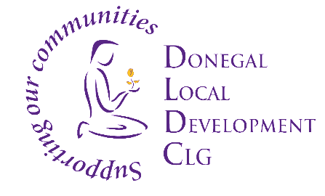

Job Vacancy

Donegal Local Development CLG is an integrated local development company established in 1995. We deliver a number of external funded programmes to the Donegal community.

Donegal Local Development CLG (DLDC) are now inviting applications for the positon of Project Co-ordinator as part of its Rural Development Programme (RDP) 2014 - 2022 (LEADER) Project. This is initially a 2-year funded role, with continuation post 2 years’, both dependent on funding.

The successful applicant will be an experienced Project Lead with work experience within the rural/ economic community arena. You will have well developed leadership, communication, interpersonal and project management skills and ability.

This role is expected to be based in Letterkenny, however flexibility may be possible with regards to location.

To apply for the position, please submit by email, a Letter of Application together with current Curriculum Vitae to: HR Department, Donegal Local Development CLG , 1 Millennium Court, Pearse Road, Letterkenny, Co. Donegal to: vacancies@dldc.org

Applications to arrive no later than 12 Noon on Friday 12th March 2021.

Job Descriptions are available from vacancies@dldc.org and also on DLDC website www.dldc.org
Interviews are likely to take place week beginning 22nd March 2021. We reserve the right to enhance the shortlisting criteria. A panel may be formed from which similar vacancies may be filled.
Donegal Local Development CLG is committed to a Policy of Equal Opportunity.
Canvassing will disqualify.
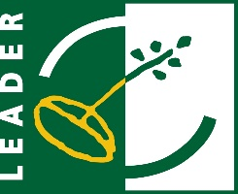
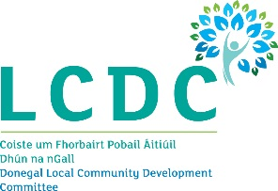
Funded by the Department of Rural and Community Development.
