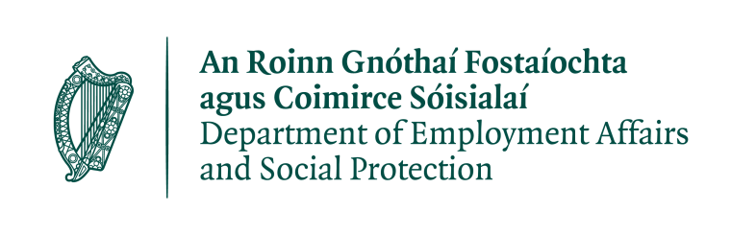

PAUL Partnership Limerick CLG manages the Limerick Local Employment Service (LES) under contract from the Department of Employment Affairs and Social Protection and now wishes to recruit a
LES ADMINISTRATION SUPPORT WORKER - TEMPORARY CASUAL HOURS CONTRACT
Based at Our Lady of Lourdes LES, Childers road Limerick city (successful applicant may be redeployed to other offices to meet service demands) and reporting to the LES Co-Ordinator, the Administration Support Worker will provide high quality administrative support for the Mediators and clients in Our Lady of Lourdes Local Employment Service.
Full Job Description and person specification is on www.paulpartnership.ie/vacancies.
Terms and Conditions

Hours of work: Monday to Friday 2pm to 5pm (15 hours).

The successful applicant will commence on the first point of the scale at €24,397 (pro-rata). All contracts are funding dependant.

Applications must be made on the PAUL Partnership Application form which can be downloaded from www.paulpartnership.ie/vacancies.

Completed application forms should be returned by 5.00 pm, Friday 25th of September 2020, by email only to recruitment@paulpartnership.ie.

PAUL IS AN EQUAL OPPORTUNITY EMPLOYER. CANVASSING WILL DISQUALIFY.
Shortlisting will apply.
A panel may be formed from which future vacancies may be filled.

