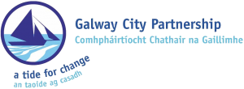

**Galway City Partnership: Vacancy**

Galway City Partnership clg (GCP) is a local development company, which provides a range of social inclusion and employment supports across Galway City.

GCP seeks to employ a full-time **Community Development & Social Enterprise Project Officer**.

Galway City Partnership is looking for a dynamic person to join our community development team. You will play an active part in the development, implementation and monitoring of GCP actions, policies and procedures and have a particular responsibility for specific elements of a range of community development actions as well as for the promotion, development and support of social enterprises in Galway City. This role is funded as part of the Social Inclusion Community Activation Programme (SICAP).

Full job description and person specification is available, together with an application form, on our website at [**www.gcp.ie**](http://www.gcp.ie/)or by contacting Imelda Gormally on 091 768305 or[**imelda@gcp.ie**](mailto:imelda@gcp.ie)

**Closing Date:  Wednesday 18th March 2020 at 5pm.**

**Interviews to take place on Tuesday March 31st 2020.**

**Please Note:**

* Late applications will not be accepted.
* Short listing will apply.
* Any details disclosed of an applicant canvassing will disqualify the job application.

Galway City Partnership clg (GCP) is an Equal Opportunities Employer.

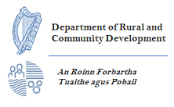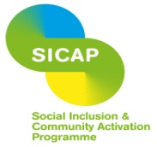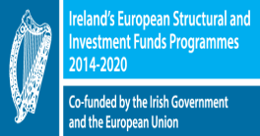

*The Social Inclusion and Community Activation Programme (SICAP) 2018-2022 is funded by the Irish Government through the Department of Rural and Community Development and co-funded by the European Social Fund under the Programme for Employability, Inclusion and Learning (PEIL) 2014-2020.*