Clare Local Development Company wishes to recruit a
HR Administrator / Assistant
(Maternity Cover: 21-28 hours per week)

The HR Administrator / Assistant is responsible for undertaking a range of administrative tasks for the efficient and compliant operation of the HR function of CLDC. The role also involves significant administrative input into the operation of the Rural Social Scheme and Tús Scheme. Relevant HR Related 3rd level qualification or on-going studies and/or CIPD Certification required.

For full job description and person specification, please email imatthew@cldc.ie

Closing date for applications is 5pm Thursday, February 27th 2020.
Completed applications to include CV and cover letter, to be forwarded to Iyabo Matthew, HR Dept., CLDC, Unit 1 Westgate Business Park, Kilrush Rd, Ennis, Co. Clare or imatthew@cldc.ie

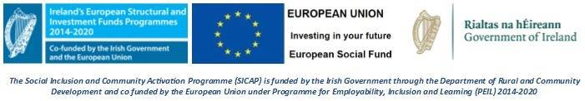
Clare Local Development Company is an equal opportunities employer

