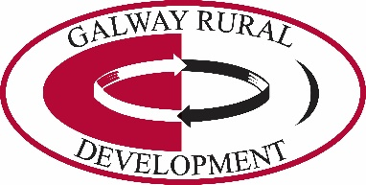

Galway Rural Development Company CLG is recruiting for an
Admin Officer/Receptionist (Full time) (Ros Muc)
To be responsible for providing reception services, clerical and administrative support to GRD in relation to the Social Inclusion Community Activation Programme (SICAP) in Connemara and the Offshore Islands.

Closing date is 12 noon on Monday 2nd March 2020.

Full job descriptions are available on request via email: grd@grd.ie or Tel: 091 844335.

Four hard copies of a C.V must be posted to the:
CEO, GRD, Mellows Campus, Athenry, Co. Galway.

Please mark on envelope “C.V. – Confidential”. An email address must be included for contact purposes.

Shortlisting will apply. Interviews will take place the week beginning 9th March 2020.
Late applications will not be considered. Canvassing will disqualify.

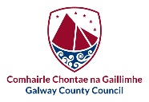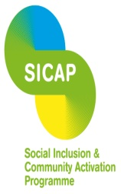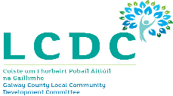
The Social Inclusion and Community Activation Programme (SICAP) 2018 – 2022 is funded by the Irish Government through the Department of Rural and Community Development and co-funded by the European Social Fund under the Programme for Employability, Inclusion and Learning (PEIL) 2014 – 2020.

