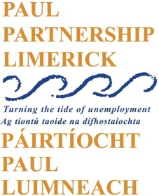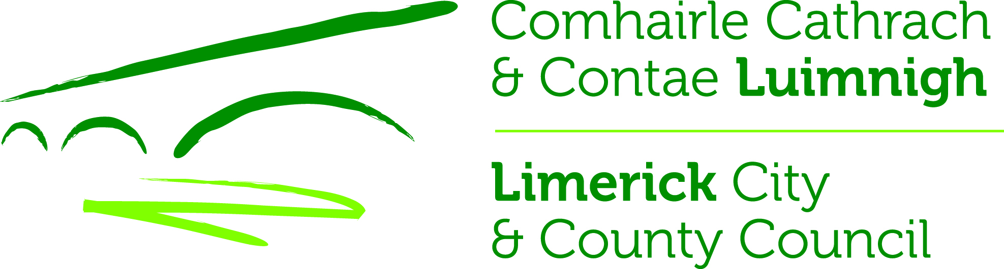

Limerick Regeneration Community Consultative Forum Development Officer

A vacancy has arisen for a part-time (21 hours per week) Development Officer.

The overall purpose of the role is to facilitate and develop the capacity of the Limerick Regeneration Community Consultative Forum to:
- Articulate the voice of residents across the Limerick Regeneration Areas on issues of common concern
- Develop and support community leadership in Regeneration areas

Job Description and Application Form can be downloaded from the PAUL Partnership website www.paulpartnership.ie

Only electronic applications will be accepted. Completed application forms by e-mail to recruitment@paulpartnership.ie

Closing date for applications is 5.00pm Monday 9th March 2020

